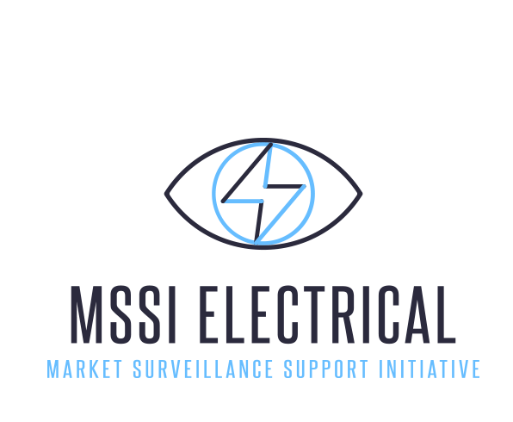

European electrical equipment industry working to help protect consumers from unsafe and non-compliant products

Brussels, 18 February 2016 – CAPIEL and CECAPI, the European manufacturers associations for low voltage switchgear and control gear, electrical infrastructure, process and installation engineering, announced the launch of an initiative to help eliminate unsafe and non-compliant electrical products in Europe to protect people, goods and property. MSSI Electrical is a CAPIEL and CECAPI initiative jointly supported by major industrial players including ABB, Benedict, Eaton, Hager, Legrand, Schneider Electric and Siemens.

Karlheinz Kaul, President of CAPIEL said: “A number of our members are working together with the key stakeholders in the electrical industry to protect people, equipment and environment with the objective of ensuring that only safe and compliant products are available in Europe”.

A lack of awareness of the dangers of unsafe and non-compliant products can cost lives, cause damage to property and tarnish or even destroy the reputation of all business owners.

Dany Sturtewagen, President of CECAPI added: “Working together, with trade bodies, market surveillance and law enforcement authorities, MSSI Electrical will provide information and training to support efforts to help ensure 100 percent of products used in Europe are safe and compliant. Some of the biggest global names in electrical product innovation are working together to raise awareness and inform the right people, including supply chain operators, customs and other government organizations.”

The industry is preparing for the application of the revised Low Voltage Directive, in April this year, which will bring more consistency in the application of legislation for manufacturers, importers, distributors and installers – with a particular focus on product traceability.

Non-compliant products are a risk to the safety of people, goods and property and can damage the reputation of individuals and businesses within the electrical industry. Every day around 12 people die in house fires in Europe and between 10 and 20 percent of fires are due to electrical faults¹.

¹ Statistics from the EU Fire Safety Network and Forum for European Electrical Domestic Safety (FEEDS)

The MSSI Electrical remit covers components for electrical installation, such as switches; circuit breakers and residual current devices, arc fault products; cable management systems; and home, building and process electronic systems – all for commercial, residential and industrial applications.

MSSI Electrical will launch a web portal, connected to all the national member organizations of CECAPI and CAPIEL. A formal launch event will be held at the Light & Building fair in Frankfurt, on March 14 this year, to engage with industry leaders, industry bodies, wholesalers, installers, end users, customs and government organizations.

ends

For media inquiries, please contact Rozenn Maréchal, MSSI Electrical Secretary: Rozenn.marechal@orgalime.org

